Oklahoma School Testing Program (OSTP) & College and Career Readiness Assessments (CCRA)
  - Kiosk Installation Guide

Spring 2018
Measured Progress is a registered trademark of Measured Progress, Inc. The Measured Progress logo is a trademark of Measured Progress, Inc. All rights reserved.
© 2018 eMetric, LLC. This document, including any and all attachments, contains the proprietary and confidential information of eMetric. It is not to be distributed to any party without the explicit written consent of eMetric.
iTester is a registered trademark of eMetric LLC.

Contents
Introduction 5
Purpose 5
Technical Support 6
OSTP Kiosk 7
Student Testing Device Requirements 7
Testing Environment 8
Testing Environment Setup 8
Network Connectivity 8
Bandwidth 9
Thin-Client Environments 10
Monitor Settings 10
Spanish Language Support 11
Language pack 11
Language Settings 11
Default Voice Settings for Text-to-Speech Accommodations 12
Disable Touch Settings for Third-Party Software 12
Windows® Kiosk Installation 13
Set up your building testing environment 13
Download the OSTP Kiosk 13
Install the downloaded kiosk 14
Windows® MSI Package Scripted Installation 18
Script Examples 18
Windows® MSI Package Installation via Group Policy 19
Windows® Network Kiosk Installation 19
Mac Kiosk Installation 20
Set up your building testing environment 20
Download the OSTP Kiosk 20
Install the downloaded kiosk 21
Disabling Universal Clipboard 24
Linux® Kiosk Installation 25
Set up your building testing environment 25
Download the OSTP Kiosk 25
Install the downloaded kiosk 26
iPad Application Installation 30
Download the OSTP app from the Apple App Store 30
Automatic Assessment Configuration 30
Chromebook™ Application Installation 31
Managed Chromebooks™ 31
Non-Managed Chromebooks 33
Managed Chromebooks™: Turn off auto-update 36
Site Readiness Test and Site Certification 38
Purpose 38
Site Readiness Testing 38
Find the Site Readiness account information 38
Authenticate every device or device configuration to be used for testing 39
Site Certification 45

Introduction

Purpose
This document is intended for technology personnel responsible for setting up the Oklahoma School Testing Program (OSTP) and the College Career Readiness Assessments (CCRA) online-testing environment in participating districts and buildings.
There are two components of the OSTP & CCRA online testing: the online portal, used by building and district administrators, and the kiosk, used by students for testing. This document contains instructions for installing the iTesterTM OSTP & CCRA Kiosk and conducting site readiness testing on devices used for online testing.
Note: the Oklahoma School Testing Program Kiosk is a version of the iTester student testing kiosk application that has been tailored for the Oklahoma School Testing Program. Some technical documentation may refer to the Oklahoma School Testing Program Kiosk as iTester.
For more information on working with the online portal, see the OSTP Portal User Guide, which is available on the OSTP Help & Support page:
http://oklahoma.onlinehelp.measuredprogress.org/guides/
To install and set up the kiosks for your building:
- Review the student testing device requirements to ensure that you have the correct equipment for student testing.
- If you have a previous installation of the OSTP app on your iPads or Chromebooks, update the app if you do not have auto-update turned on.
- Configure your testing environment to support student testing on the kiosk.
- Download and install the appropriate kiosk to each student testing device:
- Windows®
- Mac®
- Linux®
- iPad® application
- Chromebook™ application
- Complete the Site Readiness tests, which performs a system set-up check and provides a testing simulation scenario for each device or device configuration.
Tip: To ensure that the testing environment is ready for students on time, we recommend that you run the Site Readiness tests directly after installing the device kiosks.
- When all of the configurations to be used for student testing are ready, certify your site for student testing.

Technical Support
If you experience any difficulty downloading or installing the OSTP Kiosk, contact the Measured Progress Service Desk at oktechsupport@measuredprogress.org or call (866) 629-0220.
For questions about the test administration or other technical information, contact: | For questions or information regarding OSTP policy and testing procedures, contact:
Measured Progress Service Desk  Toll Free: 1 (866) 629–0220  Email: oktechsupport@measuredprogress.org | Oklahoma State Department of Education  Office of Assessments  Phone: 1 (405) 521–3341  Website: http://sde.ok.gov/sde/office-assessments

OSTP Kiosk
The OSTP Kiosk refers to the student interface used for online testing both the Oklahoma School Testing Program and College Career Readiness Assessments. The kiosk is a cross-platform, rich Internet application that employs the industry’s highest standards in security, reliability, and usability for high-stakes assessment. The kiosk runs seamlessly on Windows, Mac, and Linux operating systems, iPads, with and without external keyboards, and devices such as Chromebooks.

Student Testing Device Requirements
It is important to set up the testing environment in accordance with the student testing device requirements to ensure a proper setup for your students. The following table lists the recommended system requirements for student test devices used in online testing:
System Requirements – All Hardware
Connectivity | Student devices must be able to connect to the internet via wired or wireless networks
Screen Size | 9.7” screen size or larger/ “10-inch class” tablets or larger
Screen Resolution | 1024 x 768 or larger
Browsers  (Used for Practice Test ONLY) | ChromeTM 64 or newer ª  Firefox® 56 or newer ª  Safari® 9 or newer ª  Internet Explorer® 11  Microsoft EdgeTM 40.15 or newer
Headphone/Earphone/Ear Buds | Headphones/earphones/ear buds are required for students who have a text-to-speech accommodation
Desktop and Laptop Specific Requirements
CPU | 1.2 GHz
Memory | 2 GB
Input Device | Keyboard – wired or wireless/Bluetooth® enabled mouse or touchpad
Windows® operating system | Windows® 7, 8.1, and 10 Version 1703 (32-bit and 64-bit)
Mac OS® operating system | 10.9 – 10.13 (64-bit only)
Linux®OS | Ubuntu® 14.04.5 LTS,16.04.1 LTS (64-bit only)  FedoraTM 25, 26 (64-bit only)
Tablet/Netbook/2-in-1 Specific Requirements
iPad® | 11.2.5ª
Chromebook™ notebook computer | Chrome OSTM 61-63ª
Windows®-based tablets/netbooks/2-in-1 | Windows® 8.1, 10^{b} (32-bit and 64-bit)
ª As new operating system and browser versions are released, eMetric will update technology guidelines following successful compatibility testing.
^{b} Windows 10 S is not supported.
iTester identifies third party applications that may cause interruptions during online test administration. Users will be required to close these prior to logging into iTester. There may be additional third-party applications not currently identified by iTester that can cause interruptions or interfere with the kiosk functionality. To minimize potential security issues and interruptions introduced by these applications, we recommend disabling such third-party applications from the devices prior to conducting the operational test.
Note: students testing on devices with only the minimum specifications are more likely to encounter performance-related issues.

Testing Environment
The testing environment for a building is installed and set up by an Assessment Technology Coordinator (ATC) or by a District Test Coordinator (DTC) or Building Testing Coordinator (BTC) acting as an ATC.

Testing Environment Setup
The kiosk can be installed on the network or on an individual testing device. The advantages and disadvantages for each are listed in the table below.
Note: We highly recommend a local installation to avoid network connection issues.
 | Individual device installation | Network installation
Advantages | No impact on LAN traffic during initial application launch. | Time spent on application installation and configuration would be considerably less.  Centralized location for application updates and configuration.
Disadvantages | Time spent on application installation and configuration would be considerably more. | Downloading of the application from the network folder to the test taker’s device could introduce single point of failure during application launch.  Initial application launch could be delayed depending on the LAN traffic and bandwidth.

Network Connectivity
All devices used for student testing should have access to the Internet and should be able to access the servers using HTTP/HTTPS protocols on ports 80 and 443.
- Whitelist the following sites on ports 80 and 443 in content filtering proxies or other locally used proxy software:
- https://oklahoma.measuredprogress.org
- http://oklahoma.measuredprogress.org
- fonts.googleapis.com/
- themes.googleusercontent.com/
- googleusercontent.com/
- *.amazonaws.com
- *.newrelic.com
- bam.nr-data.net
- app.getsentry.com
- js-agent.newrelic.com
Important: If you have previously allowed these sites by IP address, oklahoma.measuredprogress.org has changed its location and will need to be re-whitelisted.
- If you are working with sandboxing applications (such as Faronics Deep Freeze TM), do one of the following while installing the kiosk:
- Choose network folder location for local caching.
- Make sure the default location, such as C:\Users\user\AppData\Local\eMetric (%localappdata%/emetric) and its contents are not deleted by these applications.
Note: Student-testing data, including encrypted responses, will be saved to the indicated location only if the network connection or Internet connection is lost during the test. Students will be able to continue testing without interruption, but their testing data will be saved in the indicated folder.
- Evaluate the type of installation for your building:
- We recommend that buildings with an Internet download speed of less than 1.5 Mbps stagger students starting the test.

Bandwidth
The ability of a school’s network to support a given volume of on-line test takers is a function of the available bandwidth between the student’s test device and the data center serving the test content, the number of students who will be downloading tests, and size of the test content. The Site Readiness test’s Connection Capacity test will measure the bandwidth between a student’s test device and the data center and determine the volume of tests that can be downloaded simultaneously. Use the results of this test to gauge the impact your bandwidth will have on testers.
Additionally, the bandwidth necessary for a certain number of students to test simultaneously (defined as actually clicking "Continue" simultaneously as that is what triggers the test content to download to the students' devices), will depend on the size of the actual operational forms. We adjust our bandwidth tests to calculate using the average form session size (which we expect will be 3 MB or less). We optimize our system and the content itself to be as streamlined and light weight as possible.

Thin-Client Environments
When using thin-client environments, such as Terminal Services, Citrix®, or LTSP®, make sure that there is enough memory, CPU, and bandwidth on the server to accommodate multiple student test sessions. The application requires a minimum of 80 MB of memory per client session and can vary depending on the size and type of the test. Allowing multiple sessions on an improperly sized thin-client environment will lead to poor performance.
Additionally, schools using thin clients need to be cautious when there is 1 GB or less of physical memory on the student testing device. In this case, we highly recommend that you use a local installation. As a general rule, if you can use Chrome™ browser to access web based email or web based streaming services on all student testing devices simultaneously, then testing should go well.
In thin-client environments, the accounts students use to log in to the student testing devices must be unique for each student. Also, each account must have its own dedicated user profile.
Note: If kiosks in your thin-client deployment experience performance issues, such as graphics not rendering, fuzzy screens, or screen flickering, we recommend disabling hardware graphics acceleration.
For assistance, contact the Measured Progress Service Desk at oktechsupport@measuredprogress.org or (866) 629-0220.

Monitor Settings
Ensure that all monitors used for testing are set to the default color settings. If a student requires a zoom accommodation, review the recommended screen resolutions in the table below.
Required Zoom Level  for Student | Recommended  Screen Resolution
100% (No Zoom) | 1024 x 768 (or higher)
150% | 1920 x 1080 (or higher)
200% | 1920 x 1080 (or higher)
300% | 1920 x 1080 (or higher)

Note: These are only recommended screen resolutions. Use the screen resolution you feel the student would be most comfortable with.
The student or proctor may set the zoom level within the kiosk when the student logs in using his or her unique user name and password at the time of testing.

Spanish Language Support
The OSTP online test administration is also available in Spanish.
The Spanish Text-to-Speech version of the tests are not available on iPads, or other mobile devices, but is supported on the following systems:
- Windows®: Windows 7, 8.1, and 10
- Macintosh: OS X 10.9 — 10.12

Language pack
The Spanish version of the test uses the Text-To-Speech accommodation, which requires a Cepstral Spanish language pack to be installed on the machine where the test will be taken.
Important: Licensing of this language pack is limited; so, plan to cycle the students with this accommodation through your testing space to avoid the need for multiple installations of this language pack.
Note: For assistance on obtaining Cepstral licenses, contact Measured Progress Service Desk at oktechsupport@measuredprogress.org or call (866) 629-0220.

Language Settings
To ensure the log in screen, navigation buttons and on-screen prompts are all in Spanish. You will change the OSTP Kiosk to the Spanish Language version.
- Launch the OSTP Kiosk

- On the Sign in Screen select Español from the localization drop down list at the bottom of the page.
You can also set up your language preferences manually on Windows and Mac workstations.

Windows workstations
- From the Control Panel, click Clock, Language, and Region, and then click Region and Language.
Note: The Control Panel commands may differ slightly depending on which version of Windows you are using.

- On the Formats tab, from the Format drop-down list, select Spanish (United States). Click Apply and then click OK.

- If you are prompted for an administrator password or confirmation, type the password or provide confirmation.

- To change the keyboard setting, on the Keyboard and Languages tab. On the General tab, click Change keyboards, and then select Spanish (United States). Click Apply, and then click OK.
- To restart your computer, click Restart now.

Mac workstations
- Choose Apple menu > System Preferences, then click Language & Region or International.
- In the Language tab, choose Spanish.
- In the Region menu, choose United States.
- When you are done customizing formats, click OK.

Default Voice Settings for Text-to-Speech Accommodations
The voice used by the OSTP Kiosk for text-to-speech is the voice set as the default on the device the student is using for testing. Ensure that the desired voice is set as the default for the operating system installed on the device.

To update the default voice for Windows® 7 and 8.1:
- Click the Start button. (Right-click the Start button if using Windows® 8.1 touch)
- Click Control Panel.
- Click Ease of Access.
- Click Ease of Access Center
- Click Use the computer without a display.
- Click Set up Text to Speech.
- Click the voice you want to use in the Voice Selection box.
To update the default voice for Windows® 10:
- Click the Windows® button.
- Click Settings.
- Click Time & Language.
- Click Speech under the time & language menu on the left side of the screen.
- Select the voice you want to use in the Voice Selection box.
To update the default voice for Mac 10.9-10.12:
- Click System Preferences.
- Click Speech or Dictation & Speech.
- Click Text to Speech
- Select the voice you want to use in the System Voice box.
Note: Text-to-speech is not supported on Linux® devices.

Disable Touch Settings for Third-Party Software
The sketch & highlight tool is not available if third-party software with touch settings is installed on the student workstation. Please see the third-party software help guide for steps to disable the touch settings.

Windows® Kiosk Installation
To install the kiosk on all student testing devices running Windows:
- Set up your building testing environment.
- Download the OSTP Kiosk.
- Install the downloaded kiosk.
You can also install the Windows® kiosk using one of the following methods:
- Windows® Scripted Installation
- Windows® Network Kiosk Installation

Set up your building testing environment
Review Testing Environment, above, in detail.

Download the OSTP Kiosk
After your District Test Coordinator sets up your Assessment Technology Coordinator (ATC) account, you will receive your user account information via email.
Note: If you do not have a dedicated ATC, a DTC or BTC can complete all ATC tasks using their DTC or BTC account.
When you have your login credentials, you are ready to download the OSTP Kiosk:
- Go to the OSTP Portal at https://oklahoma.measuredprogress.org/ and log in with your user name and password.
- On the portal home page, click Administration.
The Administration home page appears.
- Click Student Kiosk for Windows. You see a Download progress bar at the bottom of the page.
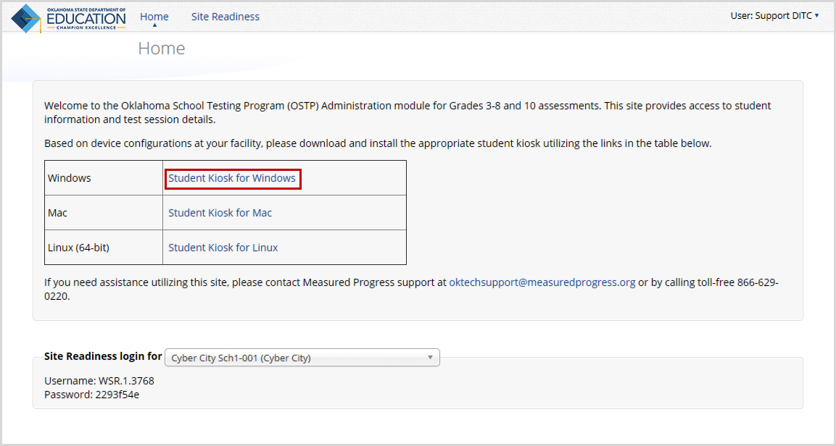

Install the downloaded kiosk
When the download completes:
- Click the Download button in the lower-left corner of the Administration home page or navigate to the file location you specified during the File Save process.
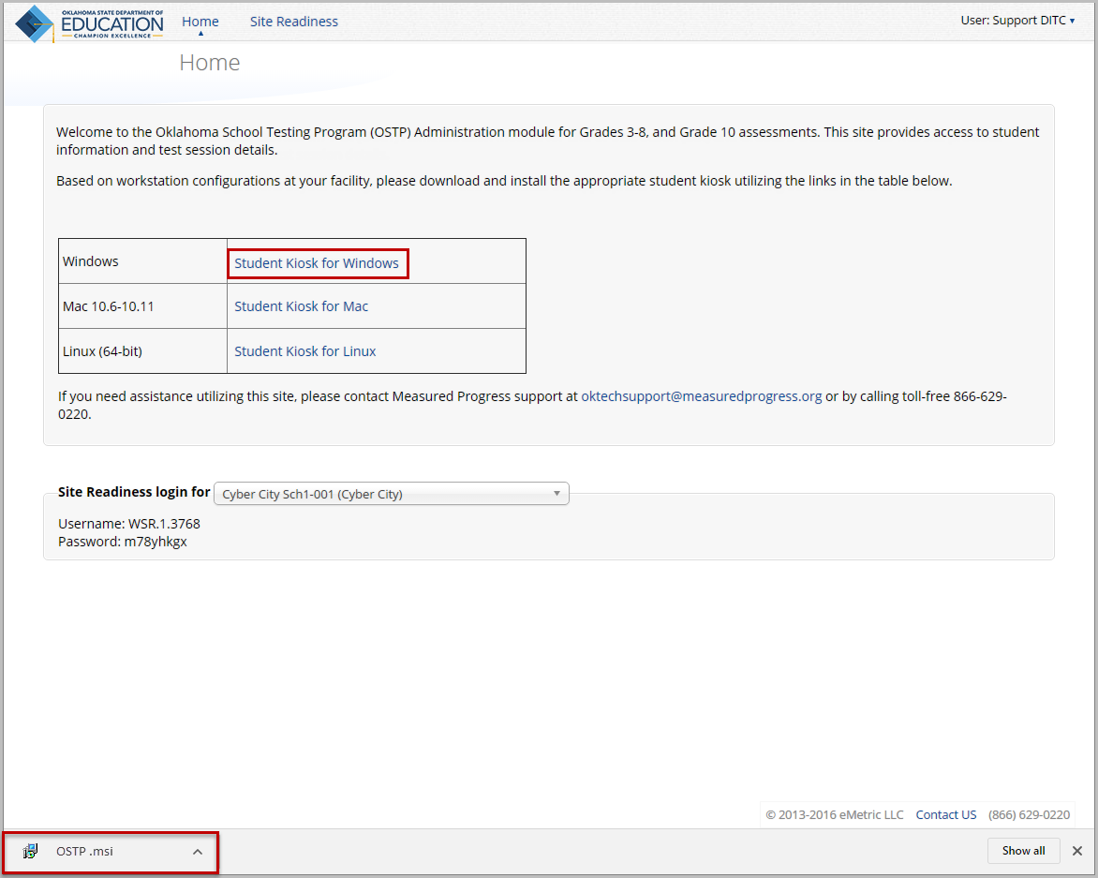

- Read the End-User License Agreement and select I agree to the license terms and conditions. Click Install to continue.
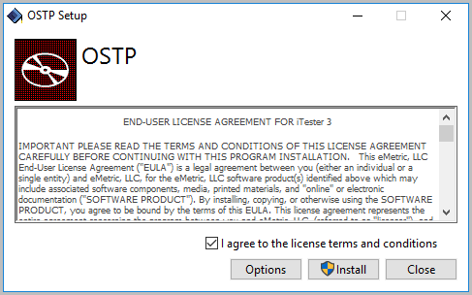
- Read the instructions and click Next to continue.
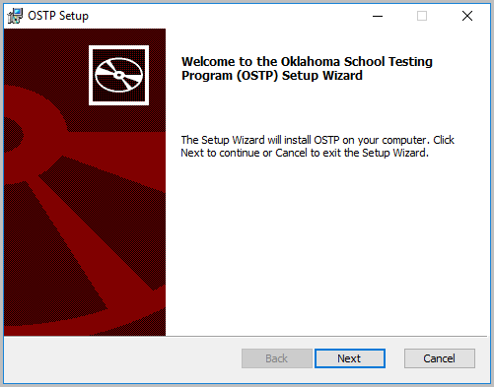

- Type the destination folder in the space provided, and click Next to continue.
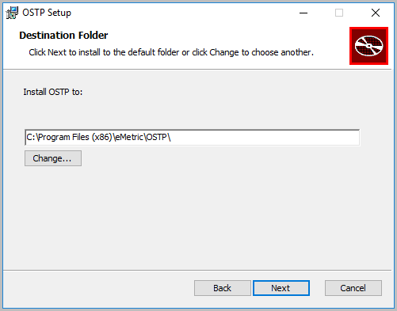
Note: You can choose to install the kiosk in a shared network folder or a local folder on the devices. We recommend a local installation to avoid network connection issues (see Network Connectivity).
- Select the directory to store student responses, and then click Next to continue.
Important: This is the failover location for saving student responses in the event of connectivity issues.
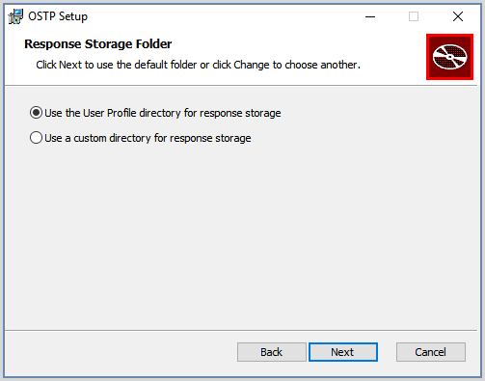
- Use the User Profile directory for caching
During kiosk installation, if you choose the default option to store the stored response files in the user profile, these files will have names similar to this format:
- Use a custom directory for caching
If you select Save in the following directory, you must manually enter the alternate path.

- Confirm that you are ready to install the kiosk, and click Install.
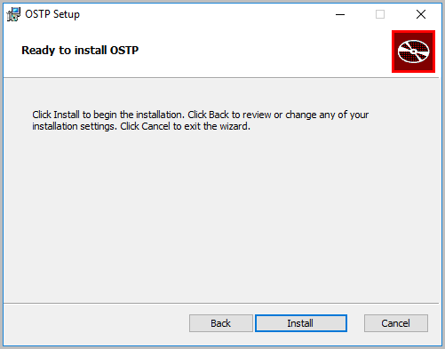
- Click Finish to complete the installation.
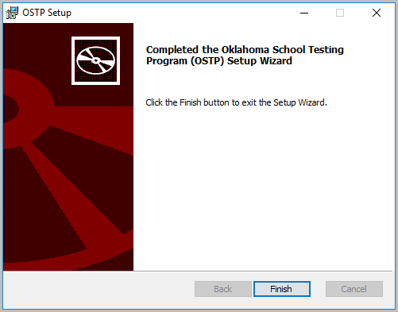
When you are ready to test the kiosk installation for this configuration, see Site Readiness Testing and Site Certification.

Windows® MSI Package Scripted Installation
Network administrators can install the OSTP Kiosk via an installation script to be executed by an Admin account in the machine. The script can be written to run without any human interaction (quiet switch) and to install in the default directory (C:\Program Files) or any target directory of choice. Uninstalling the kiosk can also be scripted.
Below are generic scripts that can be used for installation and uninstallation.

Script Examples
<Source> = Complete path to the OSTP MSI installation file, including .msi installation file name. Example: C:\Downloads\OSTP.msi
<Target> = Complete path to the location where OSTP Kiosk should be installed other than the default location (C:\Program Files). Example: C:\OSTP\Installation_Dir
<APPDATALOCATION> = Complete path to the location for storing the cache and encrypted student responses created due to network interruptions. Example: D:\Cache.
Note: Ensure that this location is excluded from system restore software like Deep Freeze.

Installation script
msiexec /I "<Source>" /quiet INSTALLDIR="<Target>" ITESTERAPPDATALOCATION="<APPDATALOCATION>" INSTALLLEVEL=2
Example: msiexec /I "C:\Downloads\OSTP.msi" /quiet INSTALLDIR="C:\OSTP" ITESTERAPPDATALOCATION="D:\Cache" INSTALLLEVEL=2
Warning!: If you do not specify ITESTERAPPDATALOCATION, then the Local Application Data folder located in the User Profile of the actively logged-in user will be used by default. If you do not specify INSTALLLEVEL=2, then the configuration required for setting the <APPDATALOCATION> will not be created.

Uninstallation script
msiexec /X "<Source>" /quiet
Example: msiexec /X "C:\Downloads\OSTP.msi" /quiet

Windows® MSI Package Installation via Group Policy
Network administrators can use Microsoft Active Directory Group Policy to distribute the OSTP MSI package seamlessly to all client computers.
Follow the step-by-step instructions described in the following Knowledge Base article: http://support.microsoft.com/kb/816102.
Note: Default installation locations will be used when using Group Policy to distribute the OSTP Kiosk. This option will also not allow systematically specifying a network location for caching and storing encrypted student responses created due to network interruptions. The local Application Data folder located in the User Profile of the actively logged-in user will be used by default.

Windows® Network Kiosk Installation
To install the OSTP Kiosk on a network:
- Complete the local kiosk installation listed above on the machine that will host the application.
- Locate and distribute the shortcut in the installation folder to the devices used for testing. This will be labeled “Shortcut to OSTP” and should point to Networklaunch.exe. In a Network Installation the Networklaunch.exe must be used for testing.
- Ensure that users have read/write/modify access to stored response directory.
- Caching Folder: Ensure that users have read/write/modify permission to their own user profile, where the application will be copied to and run from.
Individual devices require read and write permissions to %TEMP%\eMetric as the program is copied into the local %TEMP% profile by default on first-time launch from a network location. Devices without the specified read and write permissions to %TEMP%\eMetric will experience a Windows Error Code 1260 upon first-time launch in a Network Kiosk Installation.

Mac Kiosk Installation
To install the kiosk on all student-testing Mac devices:
- Set up your building testing environment.
- Download the OSTP Kiosk.
- Install the downloaded kiosk.
- Disable Universal Clipboard
Note: The kiosk for Mac devices is available only for Mac 10.9 – 10.12.

Set up your building testing environment
Review Testing Environment, above, in detail.

Download the OSTP Kiosk
After your District Test Coordinator sets up your Assessment Technology Coordinator (ATC) account, you will receive your user account information via email.
Note: If you do not have a dedicated ATC, a DTC or BTC can complete all ATC tasks using their DTC or BTC account.
When you have your login credentials, you are ready to download the OSTP Kiosk:
- Go to the OSTP Portal at https://oklahoma.measuredprogress.org and log in with your user name and password.
- On the Portal home page, click Administration.
The Administration home page appears.
- Click Student Kiosk for Mac.
Follow the instructions to download the Kiosk software to the devices.
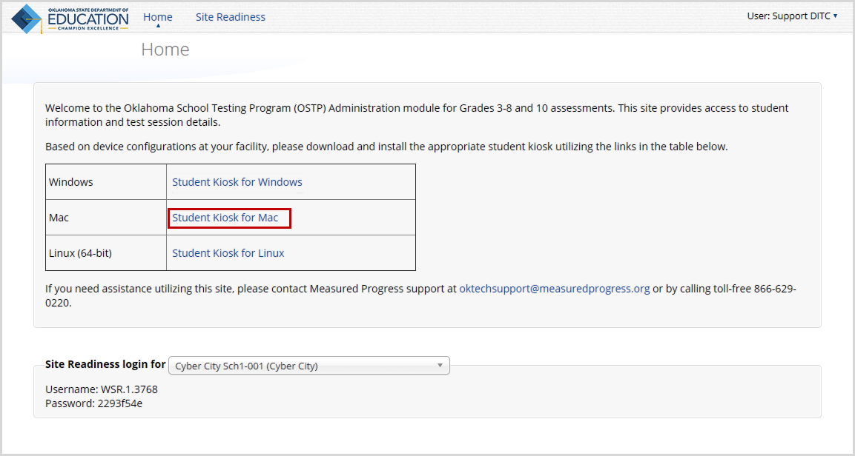

Install the downloaded kiosk
Upon completion of the download process:
- Navigate to the file location you specified during the File Save process.
- The package will run a program to determine if the software can be installed. Click Continue.
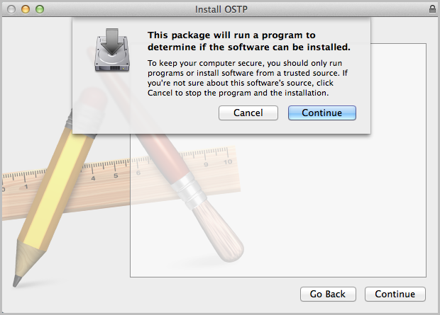
- Read the instructions and click Continue.
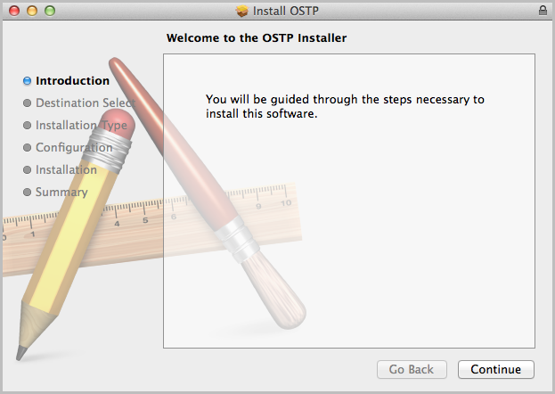

- Verify the installation type.
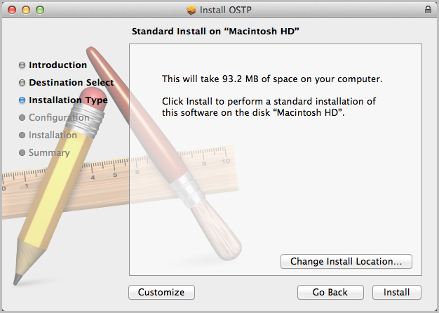
Note: To change the installation location, click Change Install Location.

- When you are ready, click Install.
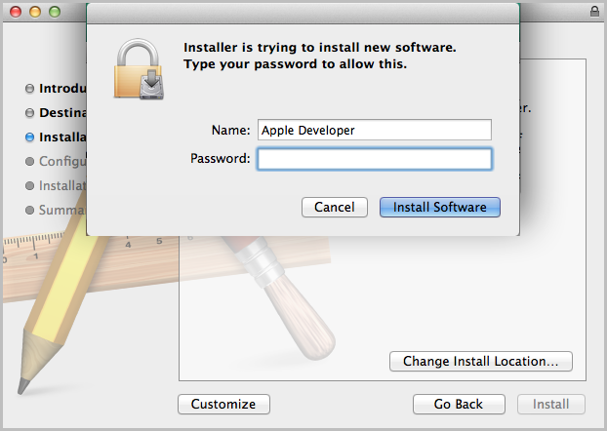
Note: You may be required to enter a password.
- Indicate where you would like to store student responses, and click Continue.
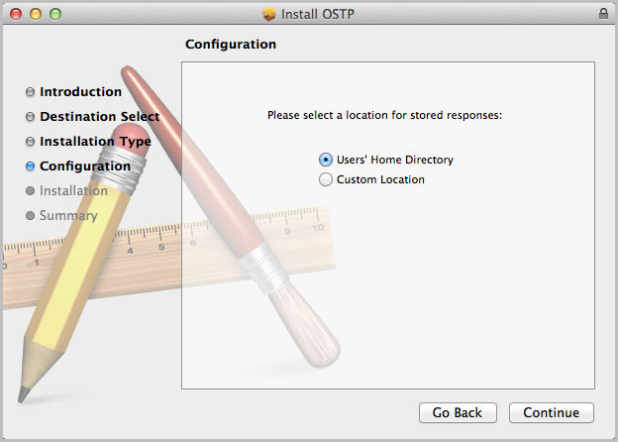
- User’s Home Directory
During kiosk installation, if you choose the default option to store the stored response files in the user profile, these files will have names similar to this format:
~/.iTester/storage/iTesterSync_AD849G-DA56-19F3-73K39823DJS3
- Custom location
If you select Save in the following directory, you must manually enter the alternate path.
Important: This is the failover location for saving student responses in the event of connectivity issues. For more information, contact the Measured Progress Service Desk at oktechsupport@measuredprogress.org or (866) 629-0220.
- When the installation is complete, click Close.
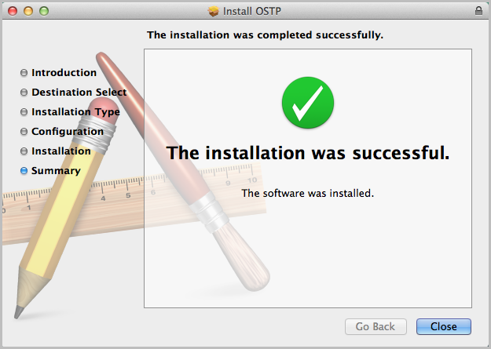
When you are ready to test the kiosk installation for this configuration, see Site Readiness Testing and Site Certification.

Disabling Universal Clipboard
Any Apple device running Mac OS Sierra (10.12.x) now has the ability to utilize Apple’s Universal Clipboard. The Universal Clipboard allows users to copy content from one Apple device to another (iPad to Mac, Mac to iPhone, etc). The following devices may use this feature:
- MacBook (Early 2015 or newer)
- MacBook Pro (2012 or newer)
- MacBook Air (2012 or newer)
- Mac mini (2012 or newer)
- iMac (2012 or newer)
- Mac Pro (Late 2013)
Disabling Universal Clipboard requires that Handoff be disabled on the Mac desktop or laptop. To disable Handoff:
- Launch System Preferences
- Select General
- Unselect Allow Handoff between this Mac and your iCloud device

Linux® Kiosk Installation
To install the kiosk on all student-testing devices running Linux®:
- Set up your building testing environment.
- Download the OSTP Kiosk.
- Install the downloaded kiosk.

Set up your building testing environment
Review Testing Environment, above, in detail.

Download the OSTP Kiosk
After your District Test Coordinator sets up your Assessment Technology Coordinator (ATC) account, you will receive your user account information via email.
Note: If you do not have a dedicated ATC, a DTC or BTC can complete all ATC tasks using their DTC or BTC account.
When you have your login credentials, you are ready to download the OSTP Kiosk:
- Go to the OSTP Portal at https://oklahoma.measuredprogress.org and log in with your user name and password.
- On the Portal home page, click Administration.
The Administration home page appears.
- Click Student Kiosk for Linux.
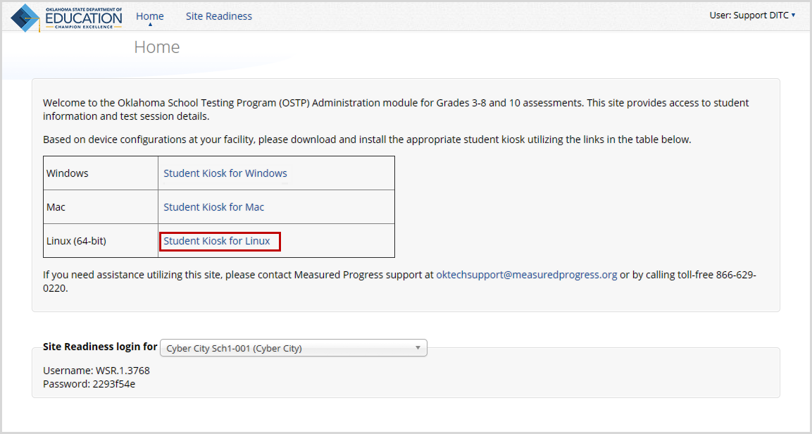
- Follow the instructions to download and extract the Kiosk software on the devices.
Note: Linux 32-bit is no longer supported.

Install the downloaded kiosk
Upon completion of the download process:
- Launch a terminal, navigate to the kiosk installer file, and execute.
- Click Yes on the Installation Page.
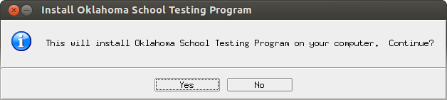
- Read the Welcome page, and click Next to continue.
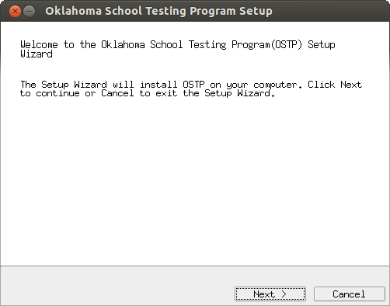

- Read the License Agreement and click I accept the terms of the license agreement. Click Next to continue.
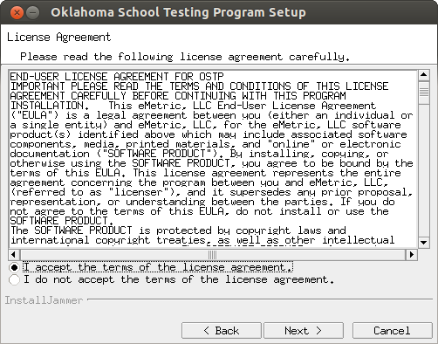
- Verify the installation folder is correct.
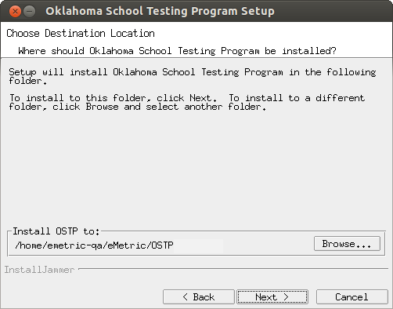
Tip: If it is not correct, click Browse to find the destination where the kiosk should be installed.
We recommend a local installation to avoid network connection issues (for more information, see Network Connectivity).
Note: This will also be the cache location to save student responses.
- Click Next to continue.
- Review the settings before the installer begins to copy files, and click Next.
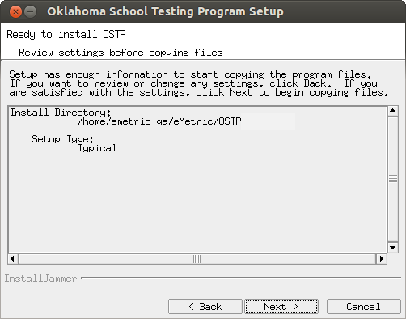
- Click Finish to exit Setup.
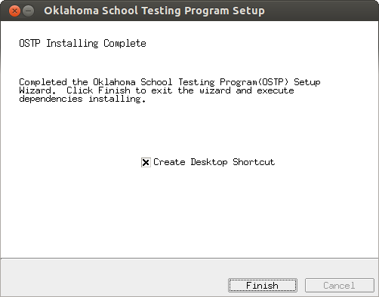
When you are ready to test the kiosk installation for this configuration, see Site Readiness Testing and Site Certification.

iPad Application Installation

Download the OSTP app from the Apple App Store
The OSTP app is available as a free download from the Apple App Store.
If you do not already have the OSTP app on your iPad, download it from the Apple App Store:
- Open the App Store on the iPad.
- Search for OSTP.
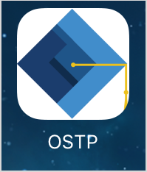
- When you locate the OSTP app, click to download it to the iPad.
When you are ready to test the kiosk installation for this configuration, see Site Readiness Testing and Site Certification.

Automatic Assessment Configuration
Beginning in iOS 9.3.2, Apple has provided a new feature to support assessments on iPad called Automatic Assessment Configuration (AAC). When you launch the OSTP App, log into a test, and then logs into a test session, AAC will automatically prompt you to enter single app mode and will disable auto correction, define, spell check, predictive keyboard, and some keyboard shortcuts. This feature helps ensure a secure test environment without requiring IT coordinators to use Mobile Device Manager Software or manually turn on guided access and change keyboard settings. AAC is the preferred method of securing the OSTP App and should be used in place of guided access. If guided access is on, it will override AAC; therefore guided access should be turned-off to allow AAC to function. No additional set-up is necessary to enable AAC.

Chromebook™ Application Installation
The Chromebook™ application is available for:
- Managed Chromebooks™.
- Non-managed Chromebooks™.

Managed Chromebooks™
These instructions are for technology coordinators who have access to their Chromebook™ device management console to administer and manage their Chromebook™ devices.
To install the OSTP app:
- As the Chromebook™ administrator, log in to your Chrome management console (https://admin.google.com).
- Navigate to Device Management, and select Chrome management.
- Click Device Settings.
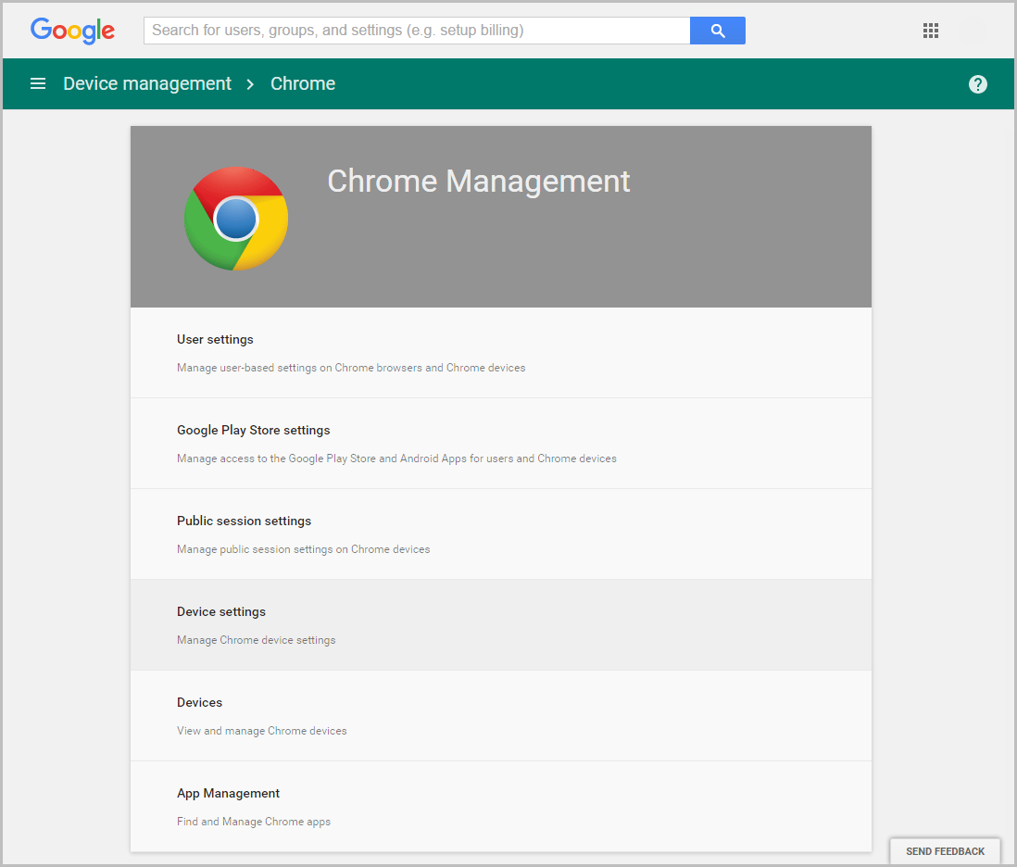
- In the Device Settings section, scroll to User Data (Erase all local user info, settings, and state after each sign-out) field, select Do not erase all local data from the drop-down list.
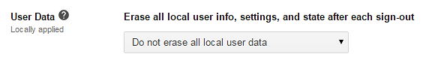
Note: This setting is crucial to allow Chrome local storage to be used to store student responses if network connectivity is lost.

- On the Device Settings page, scroll down to the Kiosk Settings section:
- Ensure that Public Session Kiosk is set to Do not allow Public Session Kiosk.
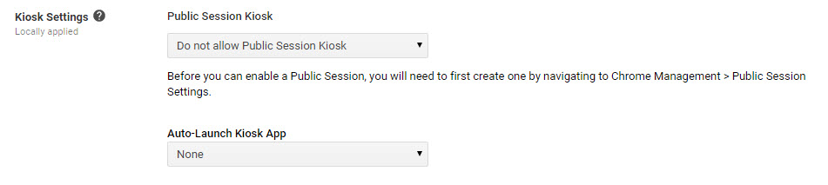
- Click Manage Kiosk Applications.
- From the Kiosk Apps window, click Chrome Web Store.
- To add the OSTP app, in the search box, type OSTP and press Enter.
- When you see the OSTP app, click Add.
The OSTP app appears in the “Total to install” section.
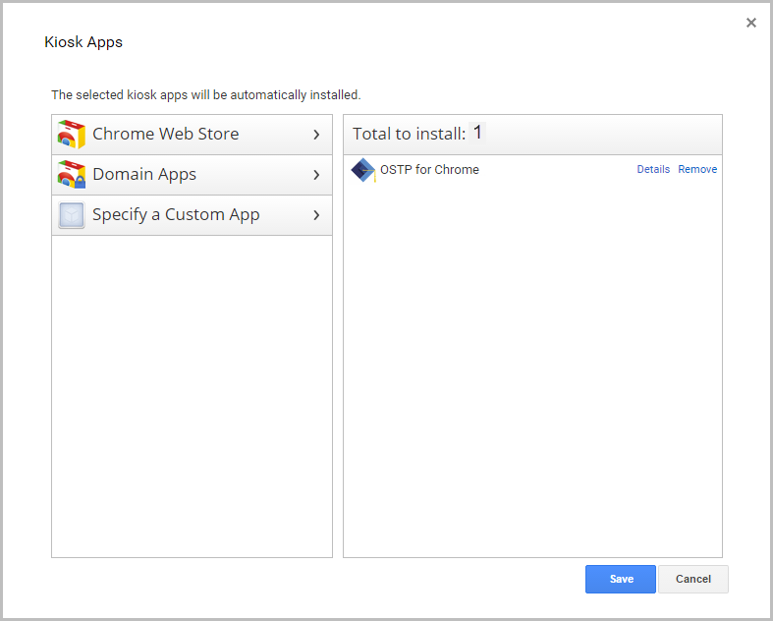
- Click Save.
When these steps are completed, the OSTP application will appear on all Chromebook™ devices that are in your domain.
When you are ready to test the kiosk installation for this configuration, see Site Readiness Testing and Site Certification.
Important: Students should not log into Chromebooks™ to take the operational test. When the managed Chromebooks™ are turned on, click the Apps link on the bottom of the log-in screen and select the OSTP app. The secure browser will open in full-screen mode.
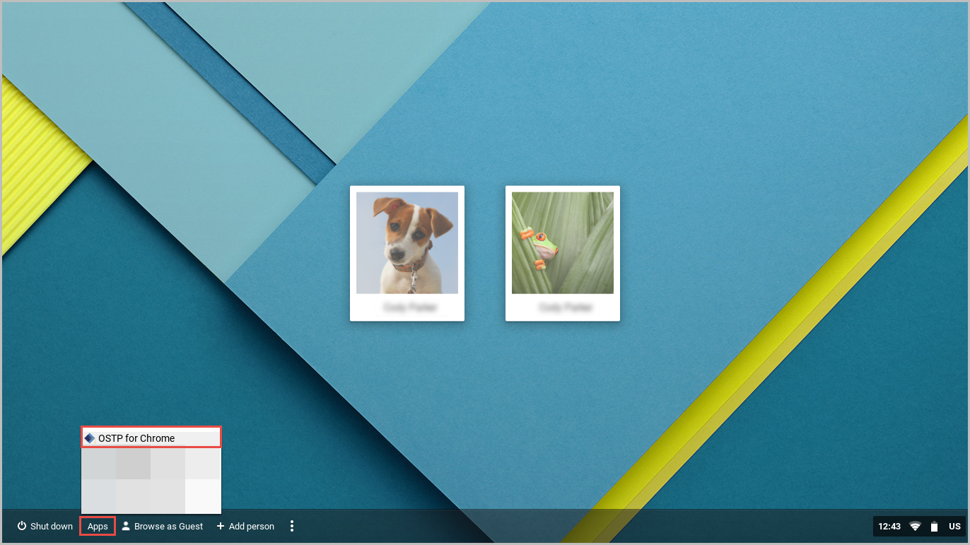
For more information, see the following links:
- Use Chromebooks for Student Assessments.
Important: Read “Scenario 1: School sets up Chromebook™ to run as a Single App Kiosk running the exam app.” Do not follow the instructions for Scenarios 2 and 3.
- Manage Device Settings, which provides general information for managed Chromebooks.

Non-Managed Chromebooks
These instructions are for installing the OSTP app onto individual, non-managed Chromebooks™.
To install the OSTP for Chrome app:
- Using the Chromebook™, search for OSTP in the Chrome Web Store and click into the OSTP for Chrome application.
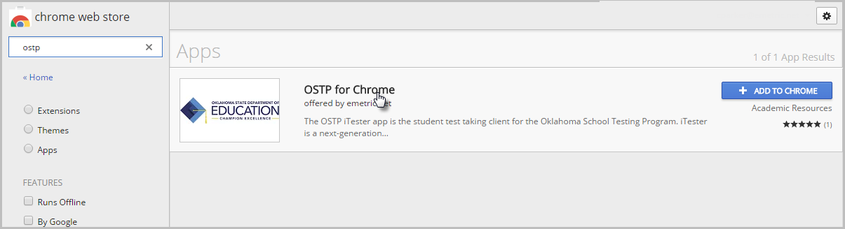
- Once the OSTP for Chrome detail page comes up, use CTRL + C on your keyboard to copy the URL of the application. Do not click the “+ Add to Chrome” button
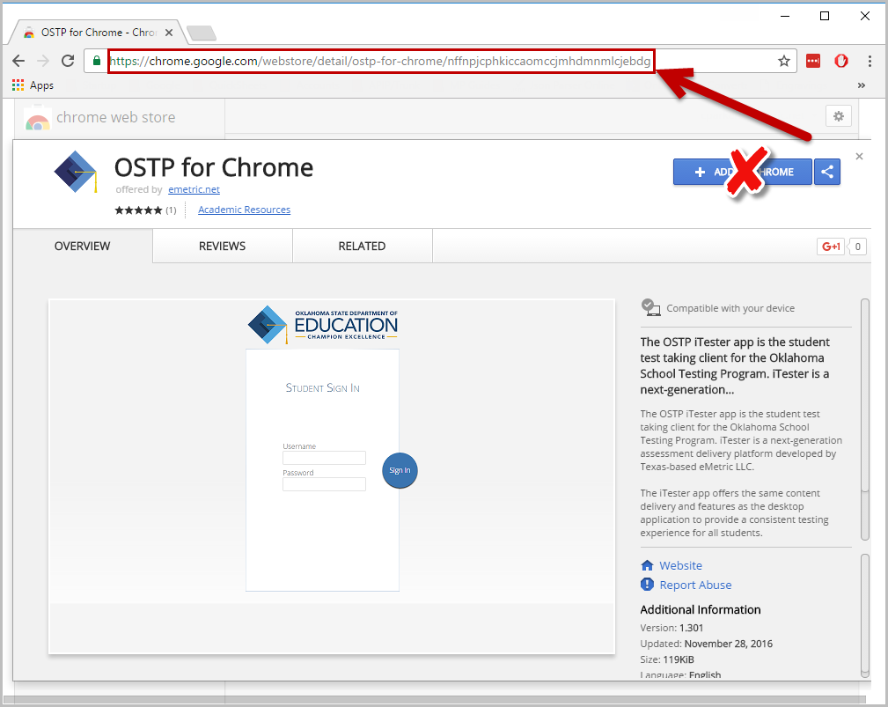
- Open a separate tab and type chrome://extensions into the search bar.
- At the top of the page, select “Developer mode” followed by Manage kiosk applications.
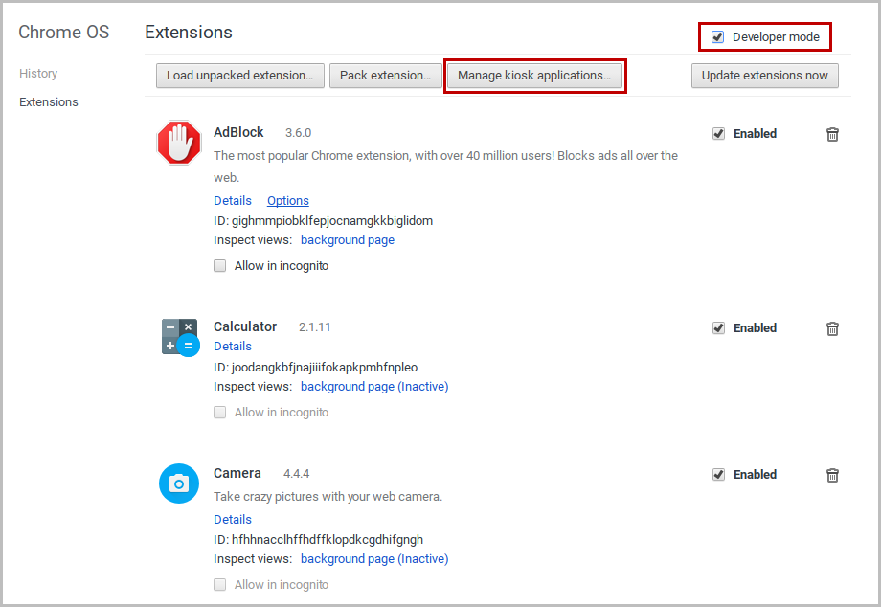
- In the Manage Kiosk Application window, paste the URL from step 2 into the “Add kiosk application:” box and click Add to add the application to the Chromebook.
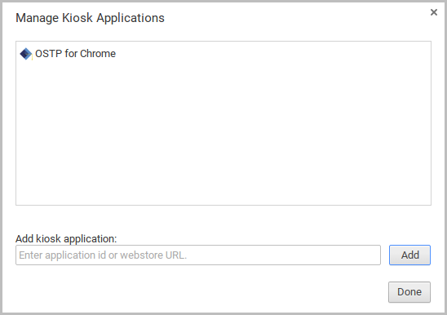
- Sign out of the Chromebook™ to return to the main login screen.
- On the login screen and prior to logging in, click Apps at the bottom left of the screen.
- To launch the app, select OSTP for Chrome.
When you are ready to test the kiosk installation for this configuration, see Site Readiness Testing and Site Certification.

Managed Chromebooks™: Turn off auto-update
For the Spring 2018 administration, Chrome OS™ versions 59-62 will be supported. Newer versions of Chrome OS™ may be released by Google during the testing window, but these newer versions will not be supported until fully tested by eMetric. Therefore, it is highly recommended that auto-update be turned off on all managed Chromebook devices until after the testing window is closed.

To turn off auto-update:
- As the Chromebook™ administrator, log in to your Chrome management console (https://admin.google.com).
- Navigate to Device Management, click Chrome Management and then select Device Settings.
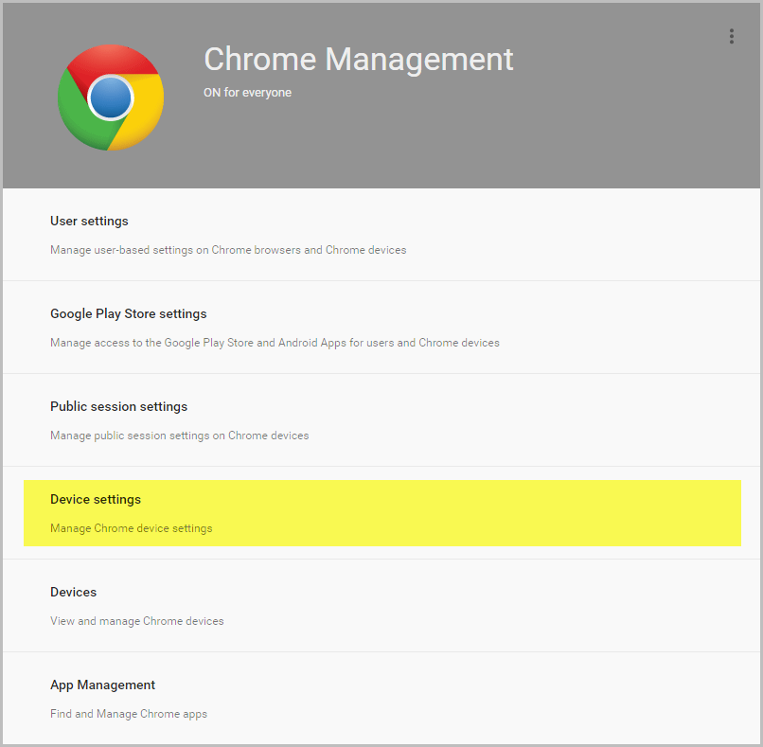
- On the Device Settings page, scroll down to the Auto Update Settings section within Device Update Settings:
- Ensure that Auto Updates is set to Stop auto-updates.
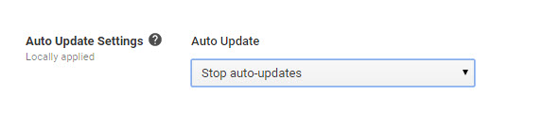

Note: Non-managed Chromebooks™ do not have an option to turn off auto-update. Therefore, use of these devices once they have updated to a non-supported version of Chrome OS™ is at the district’s own risk.

Site Readiness Test and Site Certification

Purpose
Site Readiness provides a means to identify potential technical problems prior to student testing.
Assessment Technology Coordinators will launch the kiosk on each device or device configuration being used for testing and run the Site Readiness test, which is designed to verify that student testing devices meet the minimum requirements and have been properly configured.
The Site Readiness Test includes the System Set-up Test, which checks bandwidth to the test server, connectivity to the local stored response folder, screen resolution, and audio on the student test device, and the Student Interface Test, which simulates a test scenario and will allow you to confirm that test tools and interactions are usable from the device.
Note: The Site Readiness test must be conducted on the secure kiosk and apps installed on a mobile device. The Site Readiness test does not need to be conducted on the browser used for the practice test.

Site Readiness Testing
It is crucial that the Site Readiness test be performed on every device or device configuration that is to be used for testing.
Note: The results for each device will be captured and displayed on the Site Setup page within the OSTP Portal.
To test every device configuration in the site:
- Find the Site Readiness account information.
- Authenticate every computer or computer configuration to be used for testing.
When all device configurations for a site have successfully completed the Site Readiness test, certify the site for student testing.

Find the Site Readiness account information
- Go to the OSTP Portal at https://oklahoma.measuredprogress.org and log in with your user name and password.
- On the portal home page, click Administration.
The Site Readiness account information appears at the bottom of the Administration home page.
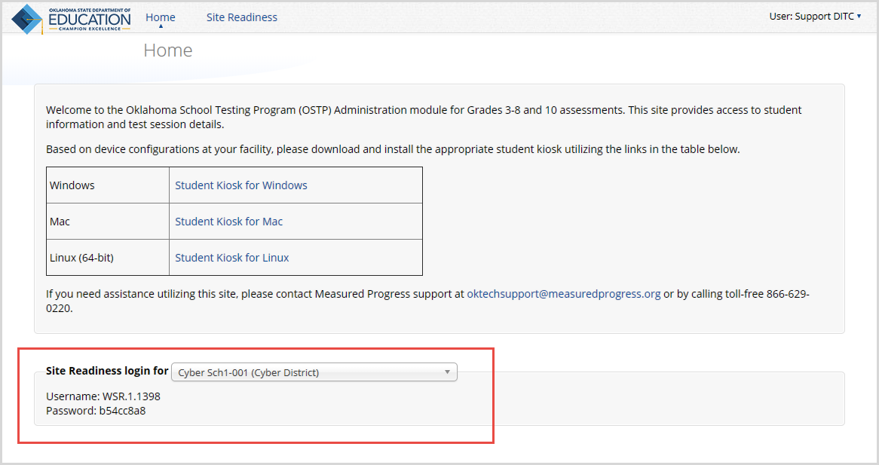
- Make a note of the user name and password for your building, which you will use to log in to the kiosk.

Authenticate every device or device configuration to be used for testing
- Launch the OSTP Kiosk on the device.
- Log in to the kiosk with the Site Readiness user name and password provided for your building.
Important: Use the Site Readiness login credentials exclusively for Site Readiness testing in your building only. Do not use the Site Readiness credentials for any other purpose or for any other building.
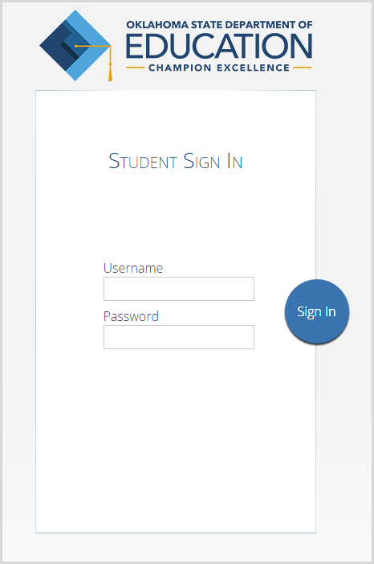
- Review the Authentication Screen to confirm your building name. In the System Set-Up Test section, click Check System Set-Up to begin the System Set-Up Test.
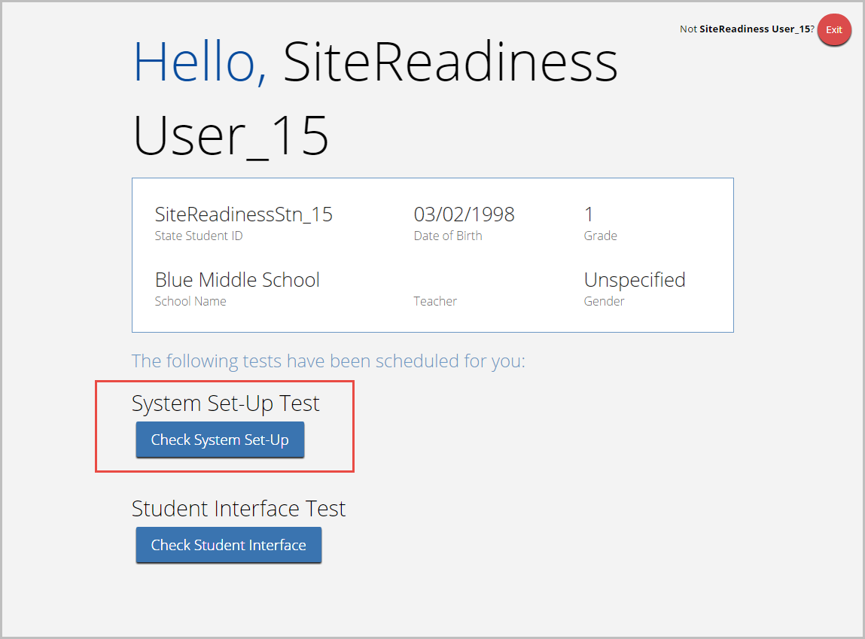
The screen resolution, host URL, and operating system for the device are listed at the top of the System Set-Up page. The results of each test appears as soon as it is completed.
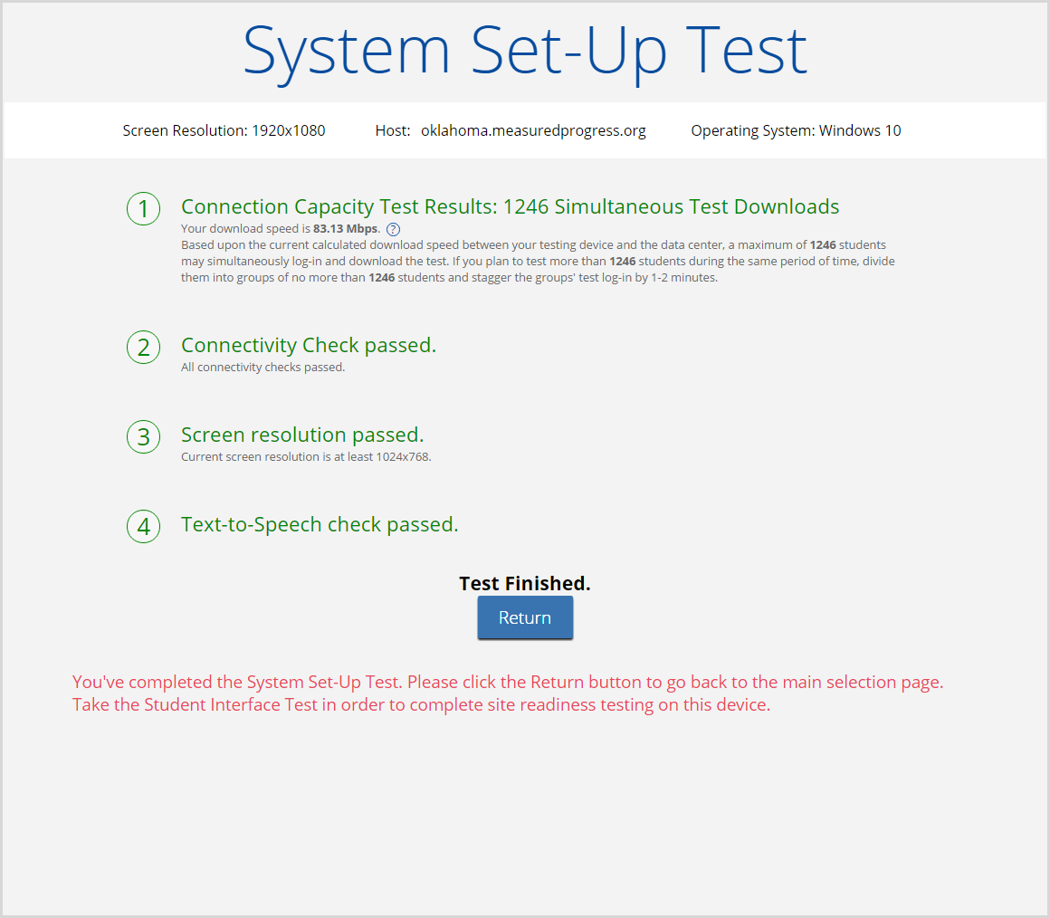
- The Connection Capacity Test evaluates your site’s capacity for simultaneous test downloads. It provides you with your current download speed between the testing device and the testing servers (data center) and based on that speed, it supplies you with the maximum number of students that may simultaneously log-in and download a test session.
If you plan to test more students than the number of simultaneous test downloads listed during the same period of time, we recommend dividing them into groups no greater than the number of simultaneous test downloads provided, and stagger the groups’ test log-in by 1-2 minutes. This will ensure that test content is downloaded without interruption.
- The Connectivity Check is designed to ensure that the testing device has access to both the kiosk’s local storage folder where student responses will be saved if the test device losses internet connectivity, and the testing servers.
- If the Connectivity Check fails with a message that says “The connectivity check failed. Please check your read and write permissions to the storage folders and try again or contact Support for further assistance. Error Code: 6004 – StorageWriteFail” this means that the OSTP Kiosk does not have the proper permissions to the storage folder. The kiosk requires the read, write, and modify permissions on Windows and Read & Write on Mac.
- If the test fails for any other reason other than “Storage location written,” please contact the Help Desk immediately.
- The screen resolution test will ensure that the testing device meets the required screen size and resolution for an optimal testing experience. If this test fails, adjust the screen resolution of the device.
- In the Text-to-Speech field, click Test Text-to-Speech to play a voice sample.
• If you can hear the voice sample, click Yes.
• If you cannot hear the voice sample, click No and fix your audio connection. Please ensure that there is a voice package installed on your machine, that there is an audio playback device connected to the testing device (internal speakers, external speakers, headphones, etc), the volume is not muted and is audible, and that the desired audio playback device is set as the default device.
- When you are done, click Return to return to the Site Readiness page.
• If all of the system set-up checks succeed, you are ready to begin the Student Interface test.
• If one or more system checks fail, adjust your configuration as needed and rerun the System Set-Up Test.
- When the System Set-Up test is completed, click Check Student Interface to begin the next Site Readiness test.

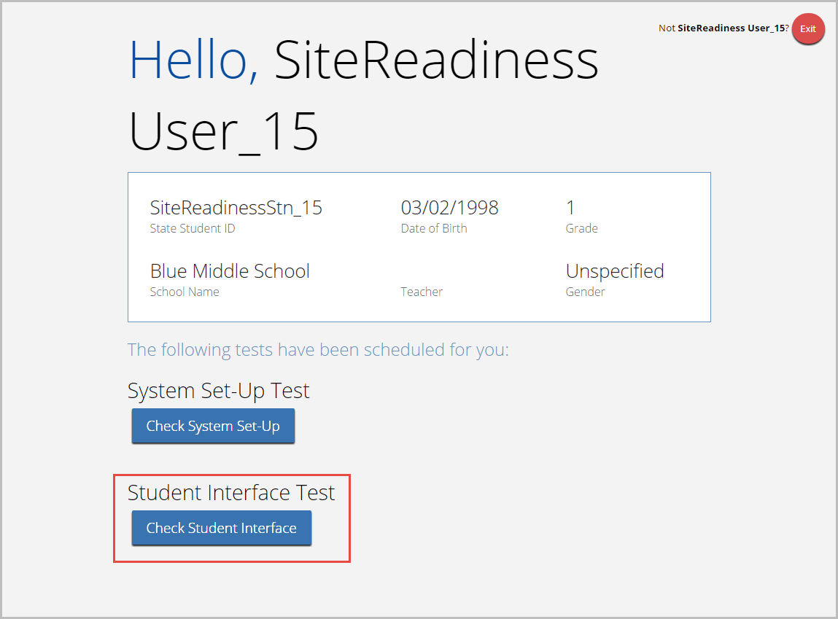

- Read instruction and then click Continue to get started.
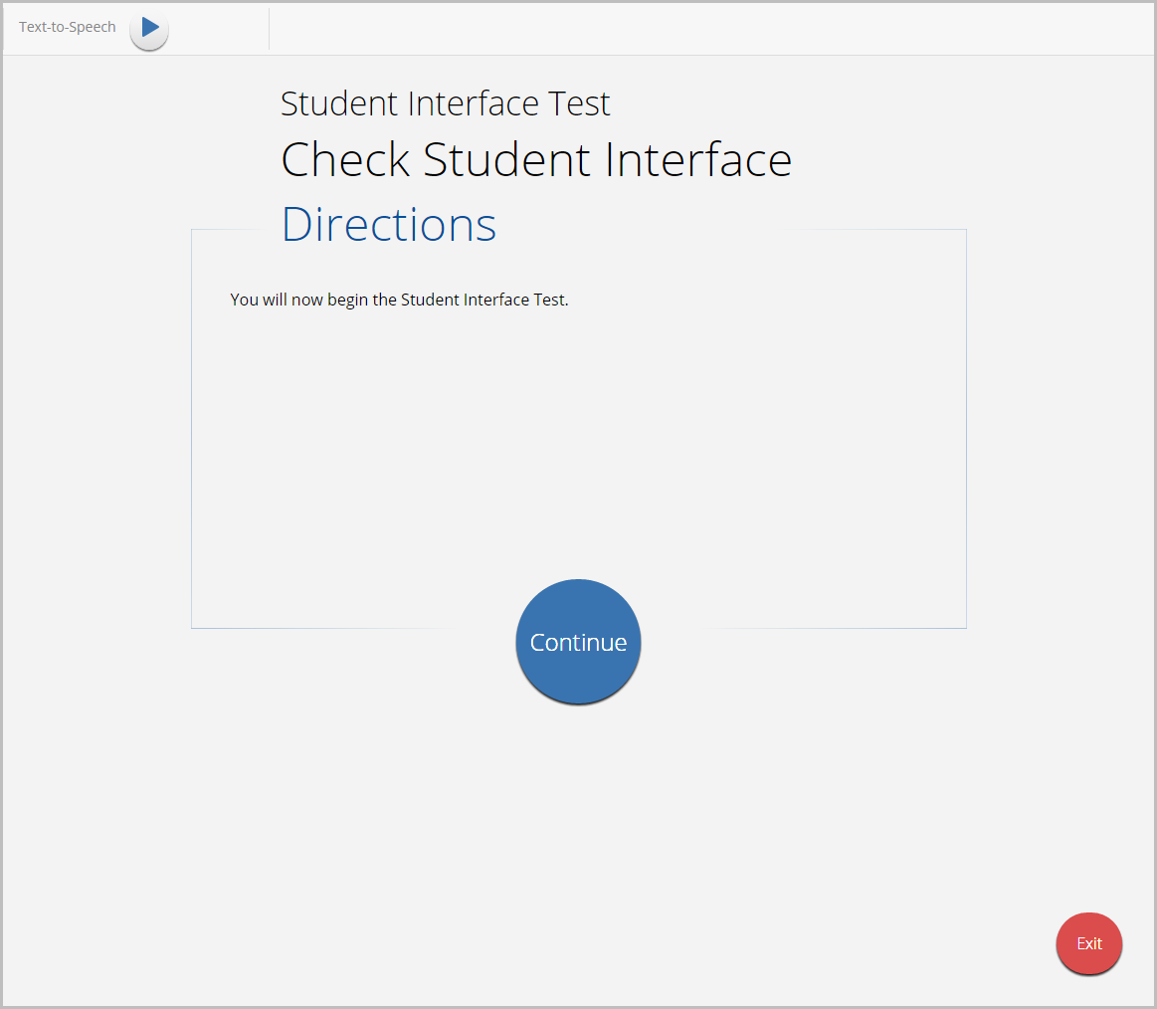
- Answer each of the test questions, using the navigation buttons on the right. Ensure you can effectively use text and drawing response tools.
- After you have responded to all items, click Finish. 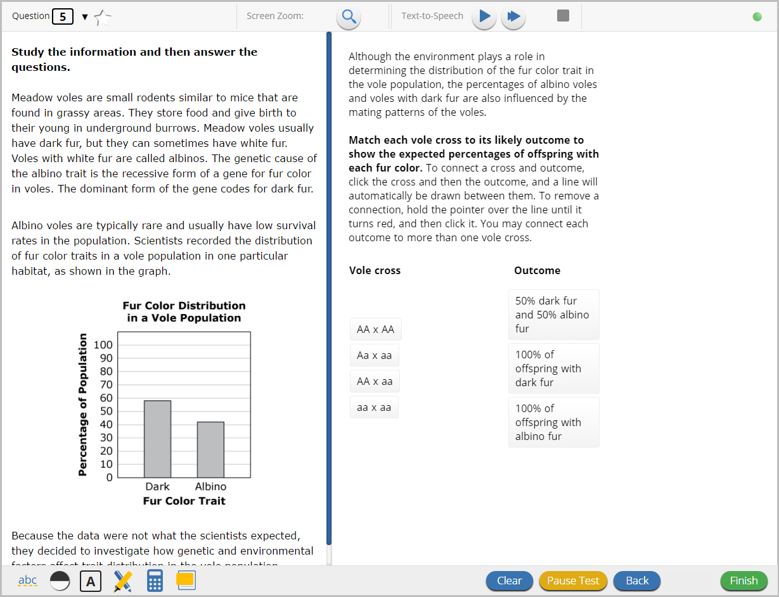
- When you are ready to submit the test, click Turn In to continue or click Return to test to return to the Test Review page.
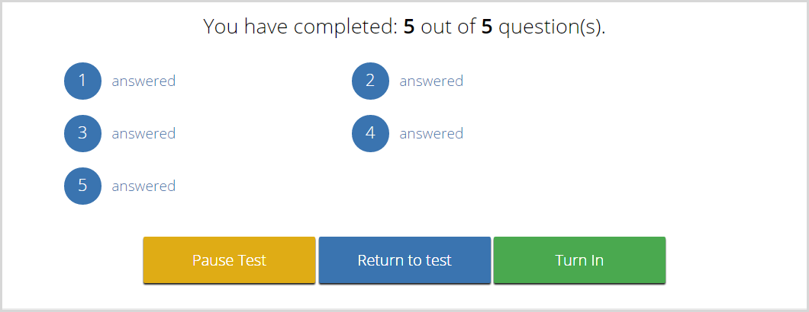
If you click Turn In, you return to the Session Selection page, where the test session is grayed out.
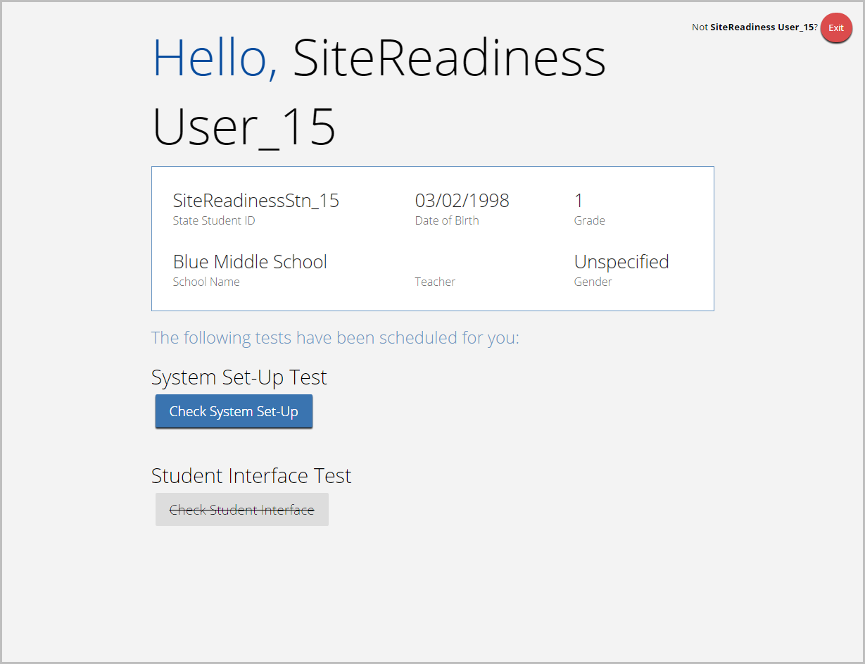
- Click Exit in the top-right corner of the page.

Site Certification
After all devices or device configurations have successfully completed the Site Readiness test, the Assessment Technology Coordinator must certify the site for testing.
- Go to the OSTP Portal at https://oklahoma.measuredprogress.org and log in with your user name and password.
- Click Administration.
- Click Site Readiness at the top of the page.
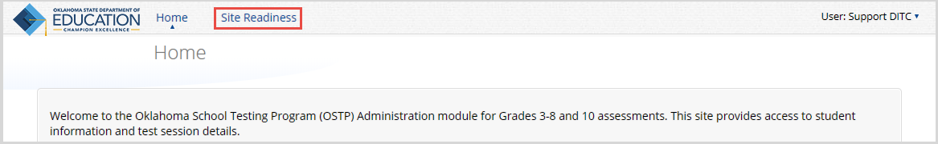
- On the Site Setup page, locate the building to be certified, and then click View Details
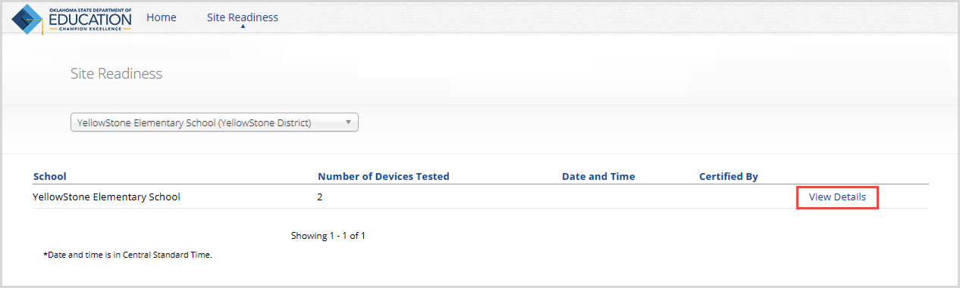
The Site Details page appears.
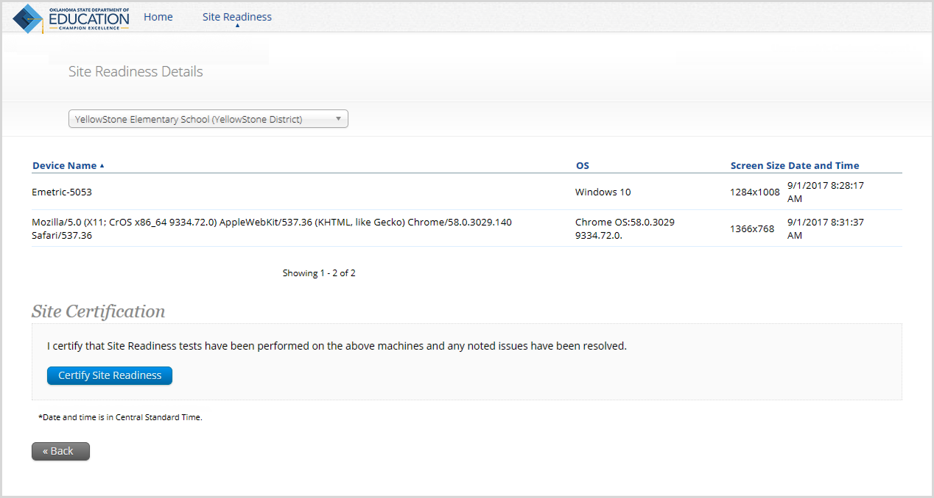

- Verify that all of the devices for this building have successfully taken the Site Readiness Test.
- In the Site Certification section, click Certify Site Readiness, and click Yes to confirm.
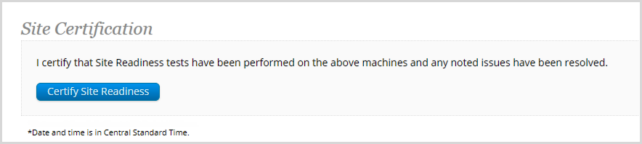
The Site Certification section updates with the date and time when the site was certified and user name of the user who certified the site for testing.
